**Genii Analytics | Copy Template | AQA**

V1. January 2021

Contents

Scope 2

Export Campaign 2

Import Campaign 4

# Scope

The purpose of this feature is to allow our staff to reuse/repurpose campaign configurations across various sites.

This function is available to anyone with a SysAdmin profile.

The process is done over two parts, namely:

1. Export target campaign from a site.
2. Import target campaign to new site.

# Export Campaign

On the home page, select Copy Template from the Admin Menu

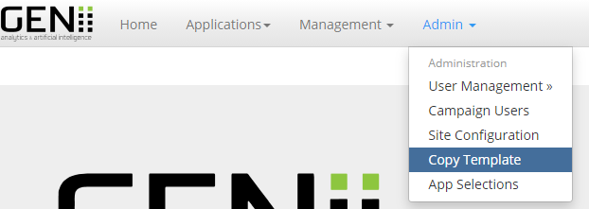

Select the campaign you wish to copy from the drop down in the Export Template Box.

(if you cannot find it here, check the status on campaign management and change it to RUN or NEW)

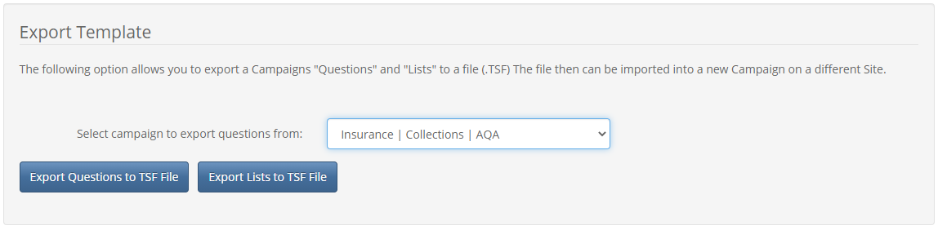

You will note that you will have to export the questions and list separately.

This is for convenience as you may not need the lists associated with the questions.

(Note, although the agent, team leader and manager list will copy over it will not implement due to people manager)

Once you have selected the appropriate campaign, you will have to decide if you need both the questions and lists from the campaign.

To export the questions, click the export questions button. (what you will find on question management or question wizard)



To export the list, click the export list button (what you will fine on list management)



Click both if required.

The files will download to your laptop download folder as .TSF files.

You can and may want to rename the files according to the campaign details if you are doing multiple campaigns or will be re-using the same questions / lists.

You can also save the files to another location.

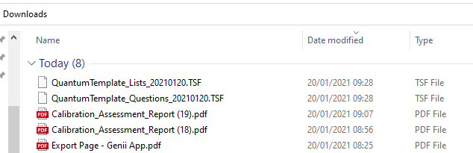

# Import Campaign

Once you have the files saved and ready for import you need to create a new campaign to allocate the lists and questions too.

On campaigns management create a new campaign and select (Blank Campaign) in Campaign Template.

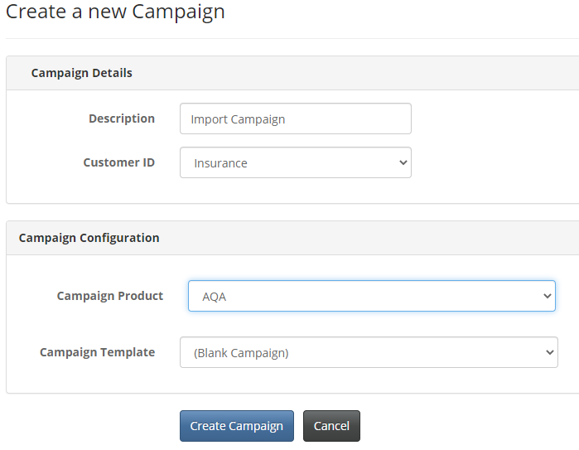

This will create a campaign with no questions or lists.

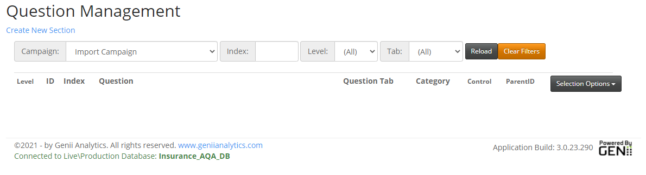

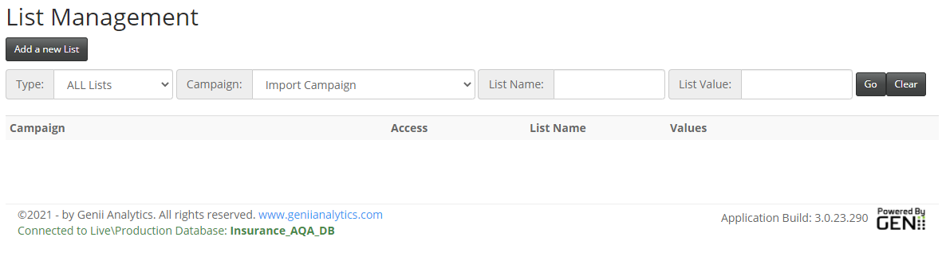

Now go back to Copy Template on the Admin menu.

You will see all NEW templates on the drop-down box in the Import a Template box.

Select the campaign you wish to import too.

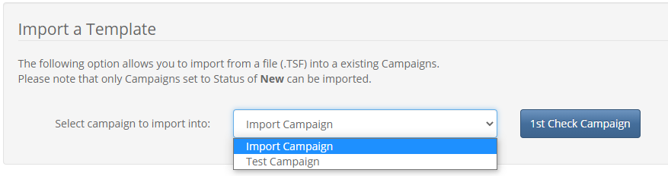

You will always be required to check the campaign before you import.

If there is data already there you will get a message as seen in the example below and you will have an option to delete this data before doing the import (preferred choice).

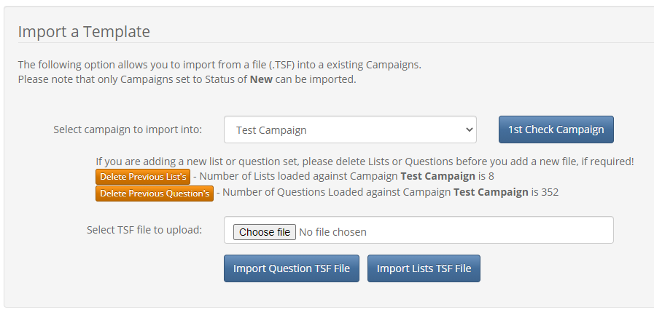

As we created a blank campaign, we will get the following message.

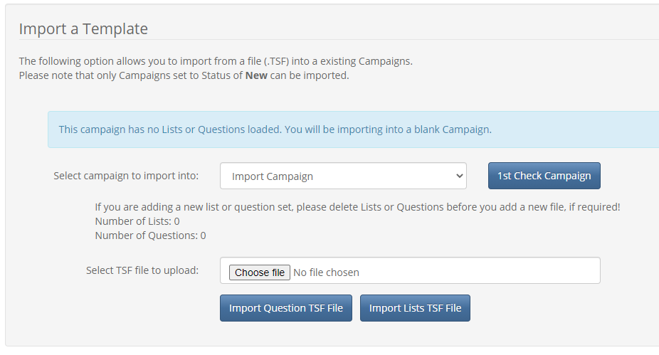

As with the export, you will be required to import the questions and lists separately as per your requirements.

For this example, I will be using a file I have renamed and stored in another location.

Click on Choose file and browse to the location you have saved the files.

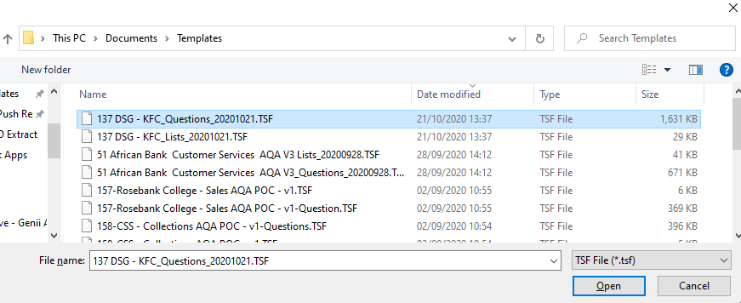

Select the file you wish to import and select Open.

The file will now appear in the Choose file box and you will need identify where it needs to go and click the appropriate button.

In the example we will be loading Questions.

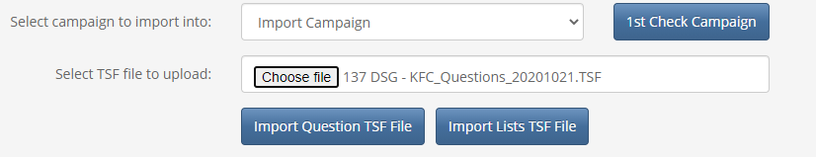

Once the import is complete you will get the following confirmation.

The list will can be uploaded in a similar fashion, selecting a list file and the Import Lists TSF File button

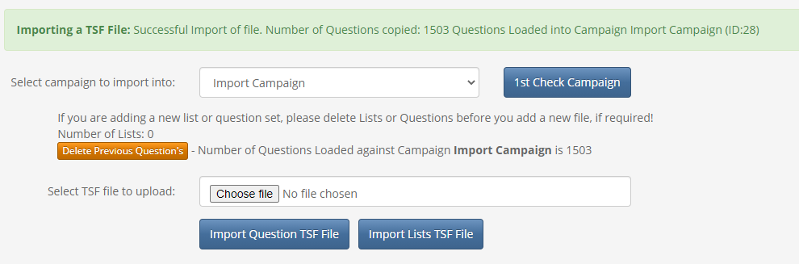

FIN